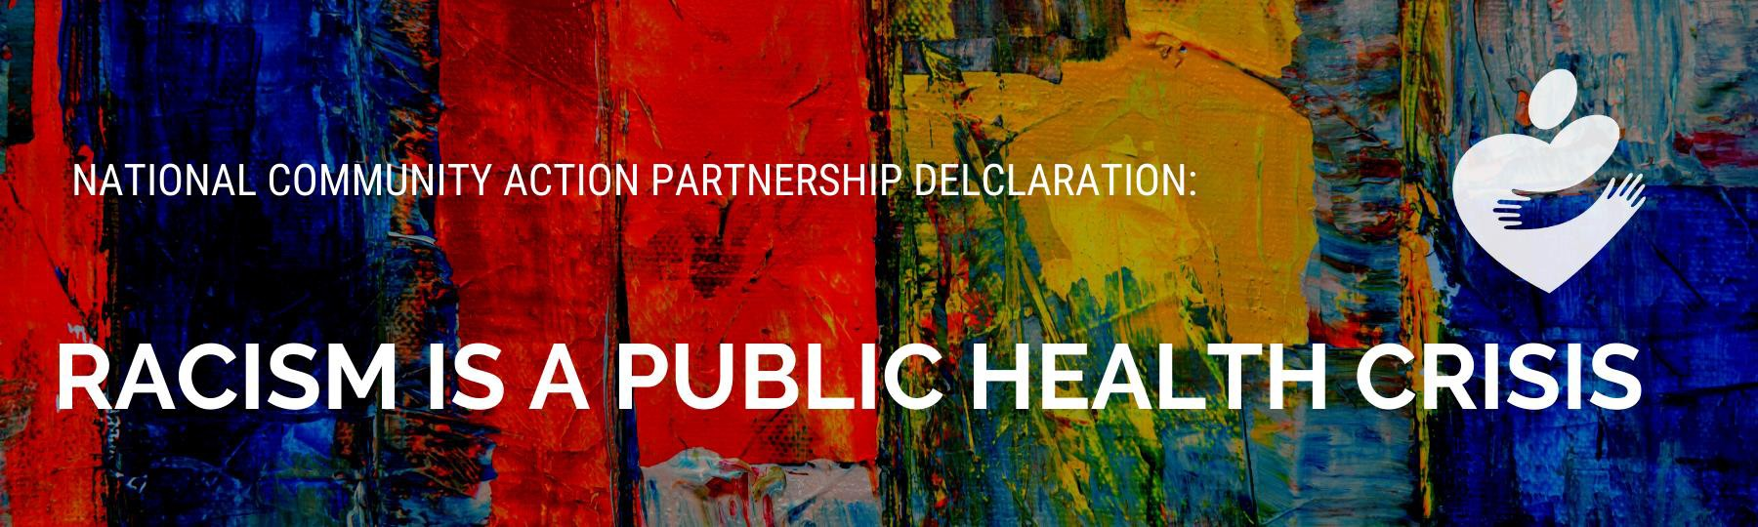

June, 22, 2021

Whereas since the colonialization of America, Black, Indigenous, Latinx, Asian, and other people of color have experienced economic injustice, social deprivation, and health inequities and barriers to opportunities based on invented racial identifiers created for the sole purpose of hierarchical discrimination and control;
Whereas the structural racism of our society perpetuates racial discrimination through mutually reinforcing systems of housing, education, employment, earnings, benefits, credit, transportation, media, health care, and criminal justice, resulting in systemic, multi-generational lack of opportunity for people of color and reinforcing discriminatory beliefs, values, and distribution of resources;
Whereas, the American Public Health Association finds racism to be a barrier to health equity and has named racism a driving force of how the social determinants of health are distributed. The social determinants of health—defined as the social, environmental, and economic factors that influence health, including employment, housing, education, access to health care, nutritious food, and public safety—are known to impact life-long health outcomes beginning even before birth;

Whereas, racism operates on systemic, institutional, and interpersonal levels, all of which operate throughout time and across generations creating harmful impact on individuals and communities of color;

Whereas, on average, white families have nearly seven times the wealth of Black families and five times the wealth of Latinx families;

Whereas the American College of Physicians has determined that people of color and Black people and Black people in particular have a higher risk of experiencing race-based discrimination and violence, resulting in physical danger and premature death;

Whereas the National Institutes of Health has found that exposure to race-based discrimination and violence can lead to negative mental and physical health outcomes, including hypertension, cardiovascular disease, depression, and death;

Whereas exposure to racism and race-based discrimination increases stress hormones, which can lead to immune system responses that result in negative health outcomes, including elevated blood pressure and increased risk for multiple mental and physical chronic health conditions, and lead to changes in brain chemistry, including inhibition of the prefrontal cortex, affecting judgment, impulse control, and educational potential;

Whereas public health experts have defined a public health crisis as one that affects large numbers of people, threatens health over the long-term, and requires large-scale solutions;

Whereas the advocacy and activism efforts against racism and race- based discrimination, for example voting rights and disenfranchisement, are often met with staunch resistance from white supremacy which marginalizes people of color, discourages equity movements, and endangers the physical and mental well-being of people of color;

Whereas the negative health effects of racism expand and exacerbate levels of poverty among communities of color;

Whereas it is the mission of the National Community Action Partnership to ensure the causes and conditions of poverty are effectively addressed and to strengthen, promote, represent, and serve the Community Action Network;

Whereas the National Community Action Partnership envisions a nation that creates opportunities for all people to thrive by building strong, resilient communities and ensuring a more equitable society for all community members;

Whereas the National Community Action Partnership believes that all people should be treated with dignity and respect and recognizes that structural race, gender, and other inequities remain barriers that must be addressed; and

Whereas the National Community Action Partnership affirms that effectively addressing the causes and conditions of poverty depends on strong, resilient communities where all members feel safe and are equally protected and recognizes that systemic and disproportionate violence against Black, Indigenous, and People of Color community members and vulnerable populations by law enforcement remains a barrier to achieving these goals; now, therefore, be it

Resolved, that the National Community Action Partnership:
- acknowledges that the effects of structural racism constitute an ongoing public health crisis;
- publicly commits to advocate for large-scale solutions and policies that prioritize the health of all people, especially people of color, and advance the achievement of racial equity;
- supports policies and programs that lessen economic and psychological burdens on families with children (especially young children) and systems that mitigate the exposure to adverse childhood experiences;
- promotes and supports policies and strategies that strengthen local communities and economies that help all individuals and families thrive, regardless of race, cultural, or ethnic background;
- publicly commits to addressing structural barriers to mobility from poverty, giving particular attention to disparities to accessing programs and services due to exclusionary policies and burdensome administrative procedures by race, gender and immigration status;
- supports policies and systems that integrate medical care and human services to improve health outcomes and economic mobility for everyone;
- supports policies and systems that create an economy that works for all with sufficient income for family well-being;
- supports policies and systems that provide equitable access to clean, affordable energy, water, and infrastructure;
- supports policies and systems that expand safe and affordable housing;
- supports policies and systems that ensure high-quality education and workforce readiness regardless of circumstance;
- supports policies and systems that promote universal health, increase physical and systemic access to healthcare resources and providers, reduce healthcare deserts—especially in communities of color, and expands mental health and substance disorder resources (especially for veteran and homeless populations) and promotes overall well-being for communities of color;
- supports policies and systems that establish structural equity in the criminal justice system and accountability of policing practices;
- supports policies and systems that protect immigrant community members;
- commits to policies and strategies that encourage civic engagement that allows every voice to be heard;
- urges members of the Community Action Network to seek out place-based solutions to structural racism that support the achievement of racial equity and address health inequities in their communities; and
- prioritizes the provision of resources and training materials to members of the Community Action Network to assist them in identifying and advocating for racial equity and economic mobility for everyone.

AFFIRMED BY THE NATIONAL COMMUNITY ACTION PARTNERSHIP BOARD OF DIRECTORS

ON JUNE 22, 2021

