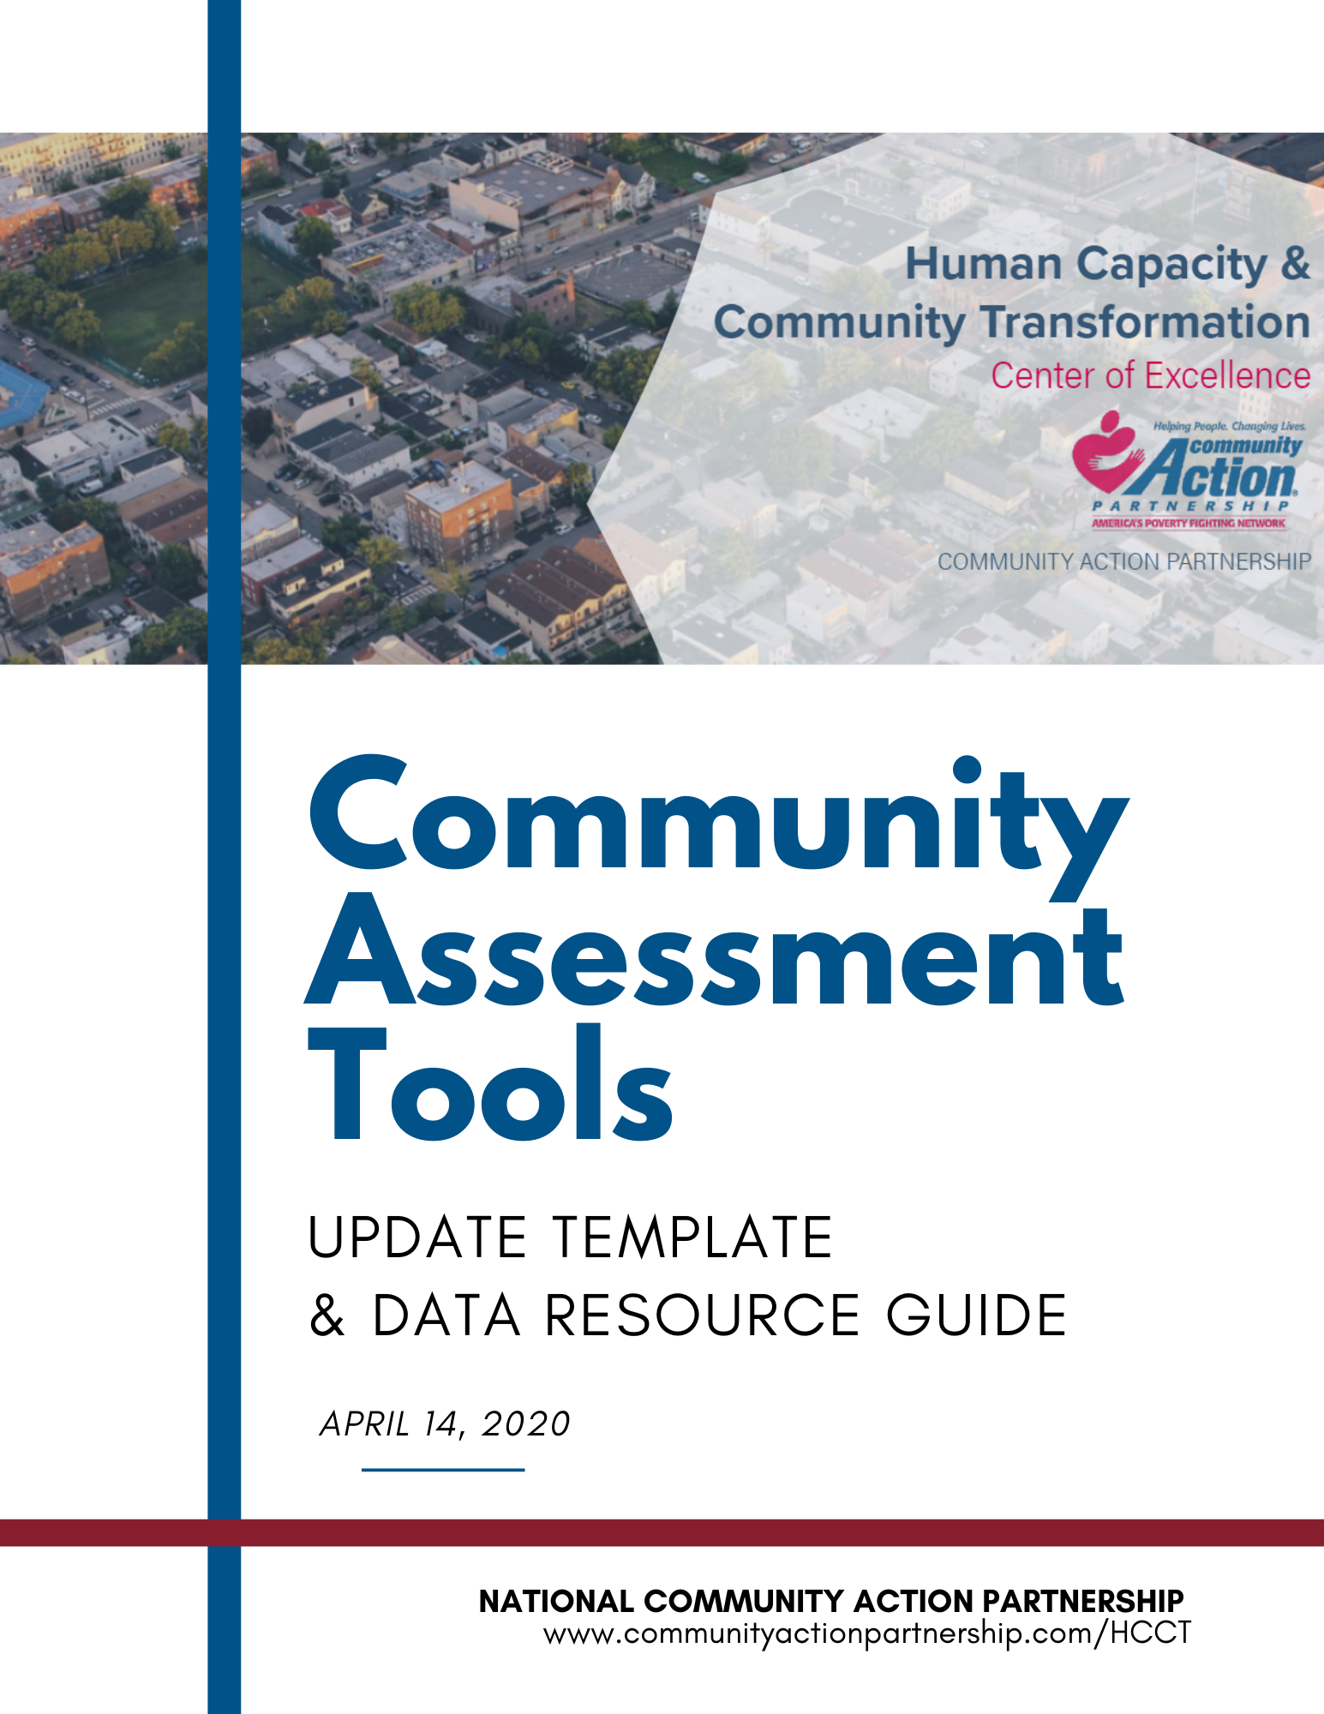

National Community Action Partnership
COVID-19 Community Needs Assessment
Update Template & Data Resource Guide

Included within this document is a Community Needs Assessment template for use by local Community Action Agencies as an addendum to their full Community Needs Assessment in response to the COVID-19 global health pandemic.
Please note: The urgent needs of communities across the United States require maximum flexibility for CAA’s to allocate resources to meet local challenges as well as a minimal administrative burden from state CSBG offices. Due to the block grant nature of CSBG funding, State offices set policies regarding whether local agencies need to provide an updated Community Assessment that addresses the COVID pandemic. If your agency is required to update its Community Assessment, this template is one tool you might find helpful to produce an update as easily as possible.
This document can serve as a foundation to the use of the special supplemental CSBG funding. Within the template is pre-filled text accompanied by places to insert local data and examples. Following the template is a data resource guide for easy access to data and resources to utilize within the template.

Initial Release Date 4/14/20. Updated 4/22/2020. This document may be updated as the pandemic progresses. Please visit: https://communityactionpartnership.com/guidance-and-resources-for-managing-coronavirus-risks/ for more information.

This publication was created by National Association of Community Action Agencies – Community Action Partnership in the performance of the U.S. Department of Human Services, Administration for Children and Families, Office of Community Services Grant Number 90ET0469. Any opinion, findings, and conclusions, or recommendations expressed in this material are those of the authors and do not necessarily reflect the views of the U.S. Department of Health and Human Services, Administration for Children and Families.

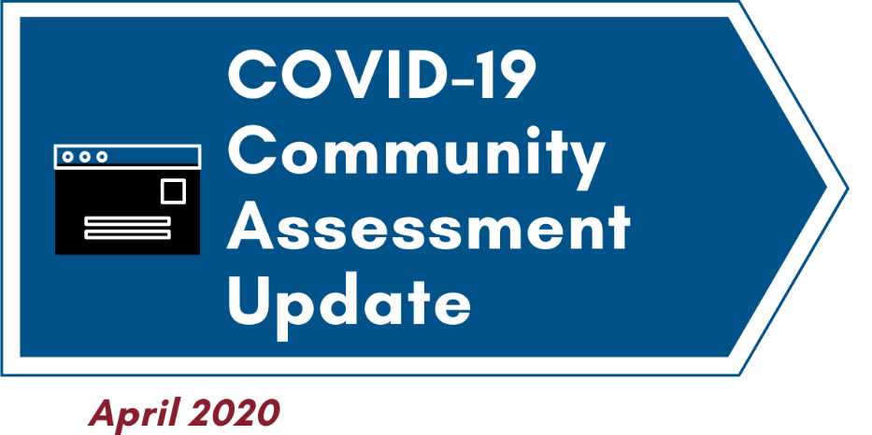

This update to the [CAA NAME] Community Assessment was completed in April 2020 in response to the COVID-19 global pandemic.
- Background
This Community Assessment Update is in response to a global health pandemic that has not only affected every community in the United States but has also led to the most significant economic disruption since the Great Depression. This assessment is an initial effort to capture some of the emerging needs in the community as well as to forecast how those needs may evolve over the coming weeks and months.
In December 2019, the novel coronavirus disease of 2019 (COVID-19) was discovered to be the causative agent for acute respiratory and flu-like symptoms and began infecting increasing numbers of people in the Wuhan Province of China. The first case in the United States was confirmed by the Centers for Disease Control and Prevention on January 22, 2020. Despite efforts to contain the virus, by March 11, 2020, the World Health Organization declared COVID-19 a global pandemic. By March 17, 2020, all 50 US States had confirmed cases of the virus.
Because of the highly contagious nature of COVID-19, the alarmingly high rate of fatalities associated with it and the lack of a vaccine or treatment, the only effective way to prevent mass illness is through restricted travel, physical distancing, frequent hand washing, coughing in elbows, not touching the face, and staying at home. By mid-March 2020, with the virus clearly past the stage of effective isolation and contact tracing, local, state and federal public health officials recommend extreme measures to minimize a public health catastrophe: mass quarantine, physical distancing, and a virtual lockdown of all public gatherings and economic activity.
While all types of people are getting sick from the disease, older adults and people of any age who experience serious underlying medical conditions, many which are more prevalent in African American communities, and, to some extent, Latinx and Native American communities, are at increased risk for severe symptoms from COVID-19. Persons of color, immigrants, and women are also disproportionately impacted by underlying health conditions linked to poverty, face discrimination in medical care, and are more likely to work jobs that require them to leave their homes. Also, persons with disabilities or chronic conditions are more vulnerable to COVID-19 due to their inability to thoroughly isolate themselves (need for hands-on care), physical impairments, environmental barriers, or interrupted services. The following additional populations experience differential exposure and extensive corresponding implications as a result of the pandemic: frontline workers, persons experiencing homelessness, gig-economy workers, low-income communities under quarantine, especially in urban settings, rural communities, tribal communities, incarcerated persons and returning citizens.
Children, families, individuals, and Community Action Agency staff may experience heightened stress, anxiety, and trauma as a result of the COVID-19 crisis. Loss of income, growing childcare needs, heightened food insecurity, housing and energy instability, lack of access to transportation, lack of basic supplies, and increased domestic violence are growing factors as the crisis unfolds.
Because of the urgent and widespread needs affecting all sectors of the community, this Community Assessment update is intended to provide some initial information to describe the scope of this crisis on our community and to support the many different responses that will be required to address emerging, evolving needs. It is likely that as needs evolve, some of those needs will not be captured in this update and therefore some necessary community responses may not connect to the needs identified in this document.
The community assessed in this document, related to the below information, is defined as the following: [label community, noting counties/state served]
The needs assessed will inform services to those affected by the crisis. It is significant to note that Congressional action will permit FY20 and special supplemental CSBG funding to serve families at or below 200% of the federal poverty level (as defined by the US Census Bureau). Specific programs or strategies will target the demographic groups most affected. Given persons of color are being disproportionately affected by both the health crisis and by the resulting economic disruption, an equity lens must be used to view current and emergent needs related to this crisis.
- Local public health response
[INSERT LOCAL DETAILS – RESPONSE OF STATE/LOCAL PUBLIC HEALTH OFFICIALS. Include the following details, if possible:
- Date of first COVID-19 diagnosis in Community Assessment Area (state/county public health dept report)
- First date state/local officials issued policies limiting activity (state/county websites)
- A list (from media accounts or official government websites) of the policies/limitations that are currently in place (effective date and expected end date, if known)
As a result of this unprecedented public health crisis, [CAA NAME] is updating its Community Assessment because there is currently a significant impact on the community, and a number of short-, intermediate- and longer-term impacts are expected.
- Immediate impacts on the community
The immediate impacts of COVID-19 have been felt across all sectors of society. In particular, some of the greatest impacts relevant to the Community Action Network have been in the areas of health, education, employment, human services provision, and community resources. In this community, vulnerability is highest in the following areas:

[Bullet geographic locations with highest vulnerability and/or use the Engagement Network’s Vulnerability Footprint tool, linked in the associated Data Resource Guide: https://engagementnetwork.org/covid-19/]

Nationwide, early data suggest that the following groups have experienced disproportionately higher rates of infection and/or complications/death as a result the COVID-19 pandemic:
- Males
- Individuals 60+ years old
- People of color, particularly African Americans
- People with underlying health conditions (especially, lung disease, asthma, diabetes, cardiovascular disease, kidney disease, liver disease, severe obesity, and individuals with immunocompromised conditions)

The following outlines the variety of impacts to the local community thus far:
[Use any from the list that apply, list additional, and supplement with readily accessible local data, examples, etc. See companion Data Resource Guide for data sources and ideas. If local data speak to any of the groups listed above – or if local data suggest other groups are disproportionately affected, cite those data here]
- Health impacts:
  - Individuals over 60, especially those with underlying health conditions have been shown to be at particular risk for severe health implications from COVID-19. [include relevant data here]
  - Community health resources will be stretched thin as resources devoted to those sick with COVID-19 will limit resources available to others.
    - [include relevant data here]
  - Mental health resources will need to be available in new and increased ways to deal with the many different stressors/traumas caused by the pandemic, especially its impact over an extended time period.
    - [include local mental health resource data or examples here – this could include noting already scarce resources or an increase in people accessing mental health services since COVID-19, if known.]
  - Nutrition for school-aged children previously accessing free/reduced breakfast, lunch, and snacks is impacted as many are now removed from that food source due to school closures.
    - [include relevant data here]
- Employment impacts:
  - Individuals in the health care field are at high-risk of exposure to COVID-19 and are under tremendous stress due to additional work hours and challenging work conditions. In particular many of those workers with close, frequent contact with vulnerable individuals are lower-wage individuals.
    - [include relevant data or local examples health care challenges here]
  - Individuals in the educational field – especially teachers and assistants in Head Start and Early Head Start as well as other early childhood care settings – are working remotely due to school shutdowns. Lower-wage workers in these fields are more vulnerable to layoffs and/or may lack the technology resources in their home to work remotely.
    - [include relevant data or local examples of Head Start/Schools here]
  - Individuals in many sectors of the economy – but particularly the service sector, the retail sectors, gig economy, and others most affected by quarantine policies – are currently experiencing sudden and unexpected unemployment. Some are unaware of resources available to them and their families as they are experiencing unemployment for the first time.
    - [include relevant data or local examples of large employers closing here]
- Educational impacts:
  - [If applicable – provide dates closures started, projected end date, If known] Closings of public schools in the Community Assessment area are having an immediate impact on children’s education. Children with less access to resources (broadband internet, computers/tablets, technology expertise, language barriers, etc.) are most at-risk for suffering learning loss during a potentially protracted period of school closure.
  - Caregivers of school-age children must secure day care arrangements for their children or sacrifice employment to care for their children. These same caregivers are also expected to be primary teachers for their children during the period of the closure. Parents with limited resources face numerous challenges as a result of this situation.

- Impacts on human services provision:
  - Services to vulnerable populations are being curtailed or drastically changed. Some service providers are not operating [EXAMPLE(s)], leaving gaps in services to the community. Other service providers have had to alter their service provision in significant ways, leaving some family needs unmet [EXAMPLE(s)]. Finally, for those service providers continuing to operate, the changed circumstances have required significant, immediate adaptations that will require additional resources to support over a longer period of time:
    - [EXAMPLES – could include things like staff training, technology upgrades, new communications platforms, additional protective measures, etc.]

- Community resource impacts:
  - The impacts of COVID-19 on community resources are numerous and include a reduction in the availability of resources (access to group activities, commercial services), a scarcity of some resources (health care, food and emergency supplies) and/or needs for resources that have not previously been required in this community in any significant capacity.
    - [EXAMPLE(S) of some of the above community-level resource impacts]
  - The broad impacts of COVID-19 on this community have created an even more urgent need for coordination and collaboration of resources among the public sector, the public health sector, first responders, educators, the business community, the faith community and many others. [CAA NAME] plays an important role convening organizations, people and resources to support families.
    - [EXAMPLES of CAA in a convening role – or evidence of need for new collaborations]

- Anticipated near- and long-term impacts
The needs above are already established through initial data and anecdotal reports from customers, staff, board members and community stakeholders. Based on these already-observed events, it is likely that there will be near-term (1-3 months) and longer-term (greater than 3 months) impacts that that require immediate planning. A partial, but not complete, list of the anticipated impacts include:

- Prolonged service disruptions
The disruptions in service delivery to customers are expected to continue for a substantial time. This is likely to lead to ancillary challenges for customers that may become long-term issues.
    - [EXAMPLES – should be connected to agency’s services. For example, a disruption to Head Start might create a need for a summer Head Start program to address learning loss.]
- Prolonged employment issues
Sudden layoffs and other employment disruptions are being addressed by emergency response measures; however, it is anticipated that long-term recovery efforts will be required to help customers reconnect to the workforce, particularly those for whom employment assistance has not previously been required.
    - [EXAMPLES – should connect to agency services, if applicable. For example, emergency services staff may require being supplemented with a job coach specializing in navigating customers through the employment assistance resource network]
- Prolonged agency capacity issues
Policies limiting in-person staff/customer interactions may be in place for an extended period of time and agencies will need to maintain remote work and remote customer-interaction infrastructure to be responsive to these needs in a more sustainable capacity.
    - [EXAMPLES – this would be an opportunity for a local CAA to describe some of the tech needs/platforms/hardware as well as other agency capacity issues (fiscal systems, HR systems, staff development)
- Prolonged community resource/coordination issues
The short-term community coordination needs cited in this Assessment are presumed to continue into the long-term. Current conditions may persist for an extended period; recovery efforts will require coordination; ongoing community preparedness to guard against a future outbreak will also require ongoing convening and new community readiness strategies based on what is shown to be effective during the current crisis.
    - [EXAMPLES –ways the local CAA may assist in convening/coordinating or what is already happening in the community, such as a VOAD/COAD]

- Addressing Equity Implications
Though immediate data may not yet be easily obtained regarding the demographics of those most impacted by the COVID-19 epidemic, previous Community Assessments, as well as countless government and academic studies have established that structural racism, xenophobia, sexism, stigmatization and othering persist – and are often exacerbated – in times of crisis. Community Action recognizes the obligation to ensure that the barriers of structural race, gender, and other inequities are addressed during this time of crisis and beyond. Therefore, it is with this lens that communities are invited to use the equity lens and the question, “why”, to understand the specific needs of the diverse populations served.

[Local CAA may want to discuss some specific groups in the local community. Engagement of customer voice in this analysis is also strongly encouraged.]

- Conclusion
[Summarize key findings and priorities here]

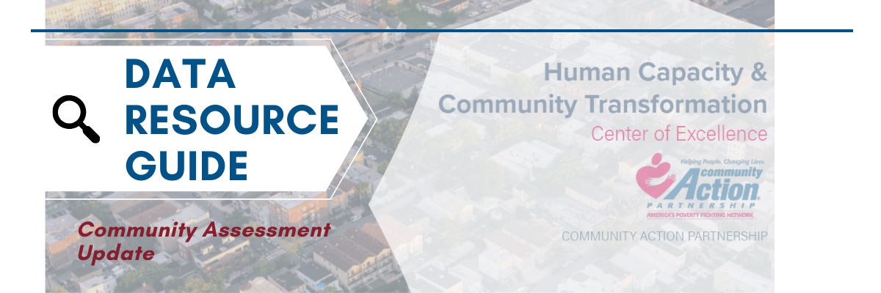
Below are data source options for corresponding sections of the Community Needs Assessment Update Template. Although there are suggested sources for each section, others may be applicable as well and general resources to also explore are listed below. State and local data sources may also be available on many of these topics. It is best to provide both quantitative (statistics) and qualitative (stories) as the information is available. Including a variety of numbers, graphs, charts, and maps is encouraged to visualize the data, as available. Given the rapid emergence of this crisis, it is also important to cite local news reports, local government activities, and any direct information from customers, staff or other key community stakeholders, since the underlying quantitative data may not yet be available.
Note: Real-time data is not available for many of the noted impact areas. However, recent data can be used to provide a case for the number of people of a particular demographic or employment group that were affected in a certain way by the COVID-19 Pandemic. For example, related to nutrition impact for children in schools most recent county-level data available is from 2018 and therefore, an agency could say, “Based on the 2017-2018 data from the National Center for Education Statistics through County Health Rankings and Roadmaps, 49% of students in Cole County, Missouri were eligible for free and reduced lunch. Therefore, approximately half of the 10,732 students in Cole County had a direct impact to their nutritional needs by the closure of schools and the lack of availability of free/reduced lunches…”

General Data Resources to Explore:
- CAP Engagement Network*, Online Community Needs Assessment Tool: https://cap.engagementnetwork.org/
  - CARES Engagement Network COVID-19 Tools & Resources: https://engagementnetwork.org/covid-19/
*note – the Engagement Network is the platform for the Community Action Online Community Needs Assessment Tool – this was previously known as “Community Commons”. The functionality is the same, with some enhancements. A username and password are required; however, access to this tool is free for the Community Action Network. Email ckohler@communityactionpartnership.com for troubleshooting.
- County Health Rankings & Road Maps: https://www.countyhealthrankings.org/
- Prosperity Now Scorecard: https://scorecard.prosperitynow.org/
- Kids Count Data Center: https://datacenter.kidscount.org/
- CDC Cases & Latest Updates: https://www.cdc.gov/coronavirus/2019-ncov/cases-updates/index.html
- National Equity Atlas: https://nationalequityatlas.org/indicators/Poverty
- Data Foundation’s COVID Impact Survey

Data Resources for Section I, Background:
The following tools can be used to identify how many people in a given area are within 200% of the Federal Poverty Level:
- CAP Engagement Network Map Room: https://cap.engagementnetwork.org/cap-map-room/ (click +Add Data, search “200% Poverty Level”)
- CAP Engagement Network, CNA Online Tool Assessment Report: https://cap.engagementnetwork.org/assessment-tool/ (select state and county; then select population profile, Poverty Rate 200%)
- Data Table: Selected Characteristics of People at Specified Levels of Poverty – 2018 ACS, 5-year estimates: https://data.census.gov/cedsci/all?q=s1703&hidePreview=false&tid=ACSST1Y2018.S1703 (then filter by the desired geography). This table allows users to access poverty data by level – i.e. 200%, 125%, 100%, <50%, etc.
Data Resources for Section II, Local public health response:
- State government health department will generally have this information. State sites can be accessed through the CDC website: https://www.cdc.gov/coronavirus/2019-ncov/cases-updates/cases-in-us.html
Data Resources for Section III, Immediate impacts on the community:
- Overall Impact (to include after opening paragraph):
  - COVID-19 Vulnerability Footprint
  - COVID-19 Starter Map – Demographic Vulnerability (can add or remove data from mapping layers)
- Health Impacts:
  - Engagement Network COVID-19 Report: Vulnerable Population Indicator - Population Age 65+
  - Engagement Network COVID-19 Report: Health System Capacity Indicators – Hospital Beds, Hospitals, Primary Care Providers
  - Engagement Network COVID-19 Starter Map: Hospitals, Confirmed Cases, and ICU Beds
  - County Health Rankings & Roadmaps Free & Reduced Lunch Eligibility Data
- Employment Impacts:
  - Utilize local examples for health care workforce challenges
  - Utilize local examples on closures for school employment and childcare challenges
    - School District Data (includes number of teachers, students, demographics): https://nces.ed.gov/ccd/districtsearch/index.asp
  - Utilize local examples on shut down of large employers or related employment challenges
    - Local Area Unemployment Statistics: https://www.bls.gov/lau/
The remaining impact categories include school closing dates and human service provision or community resource examples specific to the local area. Insert any other local area data as available or applicable.

Data Resources for Section IV, Anticipated near- and longer-term impacts:
For the section on Prolonged community resource/coordination issues, the following resource may be helpful to strategize and triage which community initiatives, or pieces of initiatives, may need to continue, pause, or end during this time. https://centerforcommunityinvestment.org/blog/reimagining-strategy-context-covid-19-crisis-triage-tool
Data Resources for Section V, Addressing Equity Implications:
The following links provide resources for understanding and addressing equity implications in response to COVID-19:
- National Collaborative for Health Equity: https://www.nationalcollaborative.org/covid-19/
- Ten Equity Implications of the Coronavirus (COVID-19) Outbreak in the United States—NAACP: https://naacp.org/wp-content/uploads/2020/03/Ten-Equity-Considerations-of-the-Coronavirus-COVID-19-Outbreak-in-the-United-States_Version-2.pdf
- COVID-19 Guidance for Higher Risk Populations—American Public Health Association: https://www.apha.org/topics-and-issues/communicable-disease/coronavirus/higher-risk-populations
- National Equity Atlas: https://nationalequityatlas.org/indicators/Poverty
- COVID-19: Mapping Vulnerable Populations in California—Othering & Belonging Institute: https://belonging.berkeley.edu/covid-19-mapping-vulnerable-populations-california
- The Unequal Impact of the COVID-19 Crisis on Households’ Financial Stability: Who is Likely To Be Immediately Hurt and Why—Prosperity Now: https://www.prosperitynow.org/sites/default/files/PDFs/Scorecard%202020/Unequal_Impact_of_COVID-19.pdf
- Coronavirus-19 Resources—Unidos US: https://www.unidosus.org/campaigns/coronavirus-covid-19/policy-priorities?utm_source=main&utm_medium=450&utm_campaign=covid
- The coronavirus is infecting and killing black Americans at an alarmingly high rate—Washington Post: https://www.washingtonpost.com/nation/2020/04/07/coronavirus-is-infecting-killing-black-americans-an-alarmingly-high-rate-post-analysis-shows/?arc404=true
- Indian Country, where residents suffer disproportionately from disease, is bracing for coronavirus—Washington Post: https://www.washingtonpost.com/climate-environment/2020/04/04/native-american-coronavirus/
- COVID-19 - Racial Equity & Social Justice Resources—Racial Equity Tools: https://www.racialequitytools.org/fundamentals/resource-lists/resources-addressing-covid-19-with-racial-equity-lens
- COVID-19: Investing in black lives and livelihoods – McKinsey & Company: https://www.mckinsey.com/industries/public-sector/our-insights/covid-19-investing-in-black-lives-and-livelihoods

Resources for Section VI, Conclusion:
For assistance with summarizing key findings, prioritization of needs, or general community assessment assistance, view our resource on Conducting a Comprehensive Community Needs Assessment here: https://communityactionpartnership.com/publication_toolkit/roma-next-gen-beyond-the-basics/
Or, in an eCourse format in Community Action Academy: https://moodle.communityactionpartnership.com/course/view.php?id=59.
