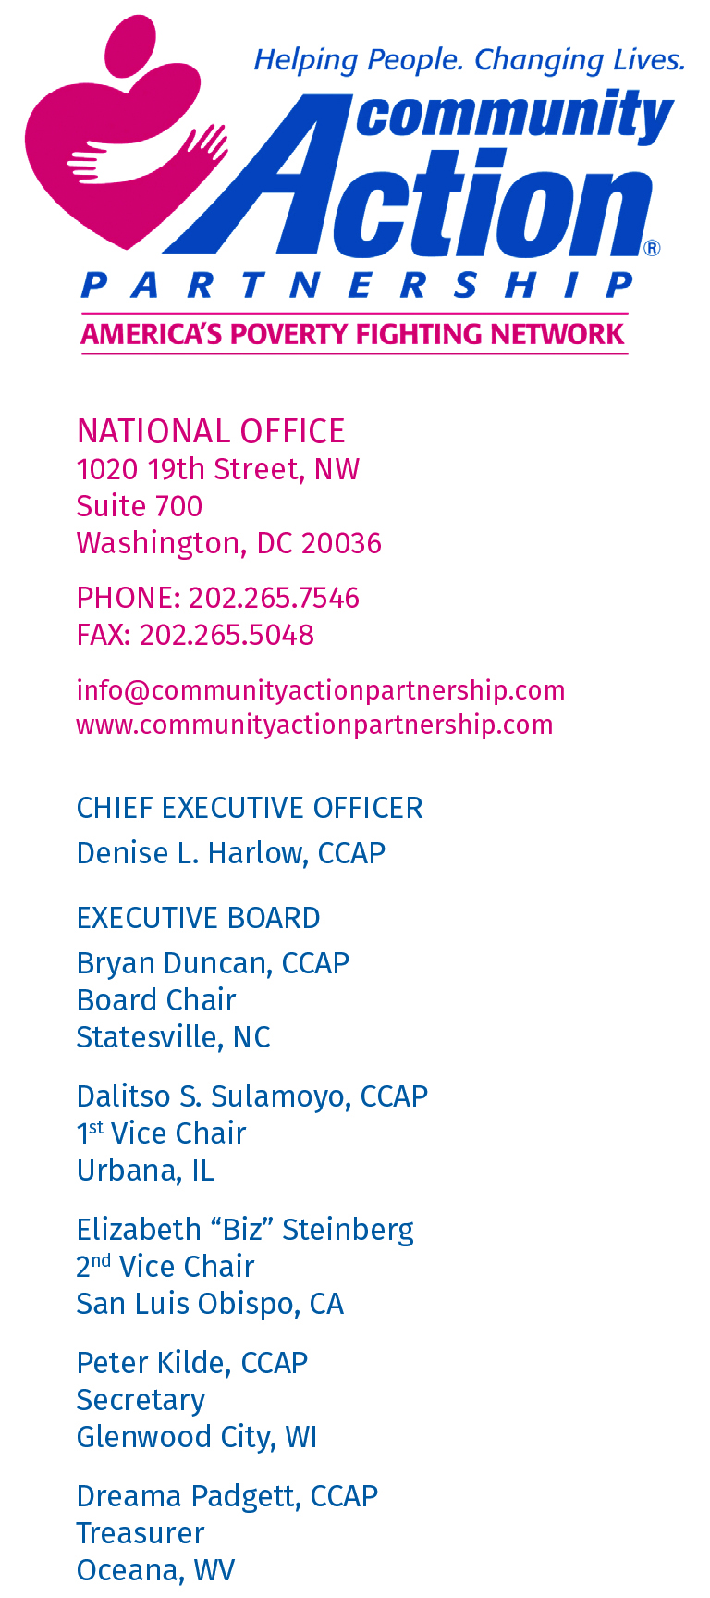
Re: OMB-2019-0002, “Consumer Inflation Measures Produced by Federal Statistical Agencies”

Nancy Potock
Chief Statistician of the United States
Office of Management and Budget
725 17th Street, NW
Washington, DC 20503

Dear Ms. Potock,
I am writing on behalf of the National Community Action Partnership (the Partnership) in response to the Office of Management and Budget’s (OMB) May 7th, 2019 Federal Register notice seeking comments on “Consumer Inflation Measures Produced by Statistical Agencies.”

The Community Action Partnership is the national hub that links the nation’s 1,000+ Community Action Agencies (CAAs) to each other and leaders looking for solutions that connect Americans to greater opportunity. Its mission is to “ensure that the causes and conditions of poverty are effectively addressed and to strengthen, promote, represent and serve its Network of member Agencies”. CAAs served over 15.8 million individuals with low incomes in 2016 alone and cover 99% of all counties in 50 states, the District of Columbia, and Puerto Rico. These comments are informed by the experience of local CAAs who work directly with the individuals, families, and communities who would be most affected by the proposed changes.

CAAs use data from measures of poverty to create programs and service delivery strategies that respond directly to the needs of the communities they serve. They also collect data on poverty levels to evaluate the success of their programs and improve performance. Furthermore, these agencies provide a wide range of programs such as the Community Services Block Grant (CSBG), Weatherization Assistance Program (WAP), and Head Start that use the Official Poverty Measure (OPM) to assess eligibility for services.

Based on the significant experience of these agencies working directly with the population who would be most affected by the proposed changes, there are a number of significant concerns about the negative impact they will have on the 39.7 million Americans who live in poverty.

The notice in the Federal Register states that OMB is not seeking comments on the impact of the proposed changes. However, before moving forward, it would be prudent for the Administration to conduct additional research and seek further comment on the accuracy of current and proposed measures of poverty and the number of individuals who would potentially lose access to critical services as a result of the change. Potential problems with the Administration’s proposal that merit further investigation include:

- Use of measures that do not accurately reflect the true extent of poverty in America’s communities;
- Restricted eligibility on programs that serve children, families, and communities most in need; and
- Risk of additional decreases in funding to programs already impacted by cuts that serve as the frontline defense in the fight against poverty.

Changes in the Consumer Price Index Will Create Incorrect Measures of Poverty

The Administration proposes to replace the current “Consumer Price Index for Urban Consumers” (CPI-U) with the “Chained Consumer Price Index” (Chained CPI) which constitutes a significant change in how inflation is measure when determining the OPM. The problem with this change is that low-income households purchase goods that experience more inflation on average when compared to households with incomes above the poverty line. For example, people with low incomes pay a larger percentage of their household budgets on housing costs compared to other income brackets. Department of Labor data shows that the cost of rental housing, the most common source of housing for those with low incomes, has been rising faster than the CPI. Because the Chained CPI shows a lower rate of inflation compared to the CPI-U, the result is an overall reduction in the poverty threshold. This means fewer and fewer individuals and families will qualify for critical programs such as the Supplemental Nutrition Assistance Program (SNAP) and Medicaid that tie eligibility to the federal poverty line.

The result of the proposed change will be to “shift the goalposts” by under-counting the number of households in poverty. Because the new measure will not in fact accurately reflect the disproportionate impact of inflation on people with low incomes, many working individuals and families will be “defined out” of poverty and denied access to programs essential to helping them achieve self-sufficiency. Additionally, because all levels of government use poverty data to calculate allocation of resources, an incorrect count of those in poverty will likely result in the further reduction of support to economically vulnerable populations.

Incorrect Measures of Poverty Will Reduce Program Eligibility and Enrollment for Critical Services

Many studies, such as the National Academy of Science’s “Measuring Poverty: A New Approach”, point to problems with current poverty measures. Indeed, the federal government’s own Supplemental Poverty Measure (SPM) was developed because existing measures failed to account for costs like child care that affect many families with low incomes. The Administration’s proposed change would take a measure that fails to adequately reflect the full range of factors that contribute to poverty and further simplify the calculation by using an indicator that under-estimates the impact of inflation on those most in need of support. This mistake will further compound over time as the Chained CPI lags farther and farther behind the real costs of inflation experienced by individuals and families with low incomes.

The immediate impact of the proposed change could potentially harms millions of Americans by defining them out of poverty and denying access to programs such as WAP, SNAP, Head Start, and the Low Income Home Energy Assistance Program (LIHEAP) that use federal poverty guidelines to determine eligibility. The Administration has provided no information as part of the Request for Comment that shows how the proposed changes would affect the most economically vulnerable Americans who rely on these programs as a pathway out of poverty. Given the significant impact the use of the Chained CPI will have on both the calculations used to determine the number of people in poverty and eligibility for programs, the Administration should conduct additional research on this important issue. This should include a review of the disparate effects of inflation on people with low incomes, estimates of how the proposed changes would affect the number of people defined as living in poverty, the number of individuals and families at risk of losing eligibility for programs, and the affect on service providers.

The False Perception of Lower Poverty Rates Will Further Reduce Funding for Programs

An innacurate count of the number of individuals and families in poverty will have broader effects on human services that constitute an essential investment in the development of individuals and the economy. An artificially low estimate of the poverty rate will inevitably be used to call for further reductions in funding for these important programs. Decreases in federal support will also mean that state and local resources will have to stretch even further to meet the needs of the working poor and those who can least afford further cuts to vital programs that provide for nutrition, early education, housing, and other essential services.

For these reasons, the Partnership strongly opposes the changes to determining the poverty line proposed in the May 7th Federal Register notice and request that further study be given to this important issue. The focus on consumer inflation fails to account for broader problems with how the Official Poverty Measure is determined as illustrated by the federal government’s own work on the Supplemental Poverty Measure and research conducted by numerous national organizations.

Thank you for the opportunity to provide feedback on the proposed changes. Please feel free to contact us directly if we can provide any additional information or support for the process. We look forward to working with OMB and the Administration on this critical issue that affects the well-being and economic stability of millions of Americans with low incomes.

Sincerely,

Denise Harlow
Chief Executive Officer
Community Action Partnership

