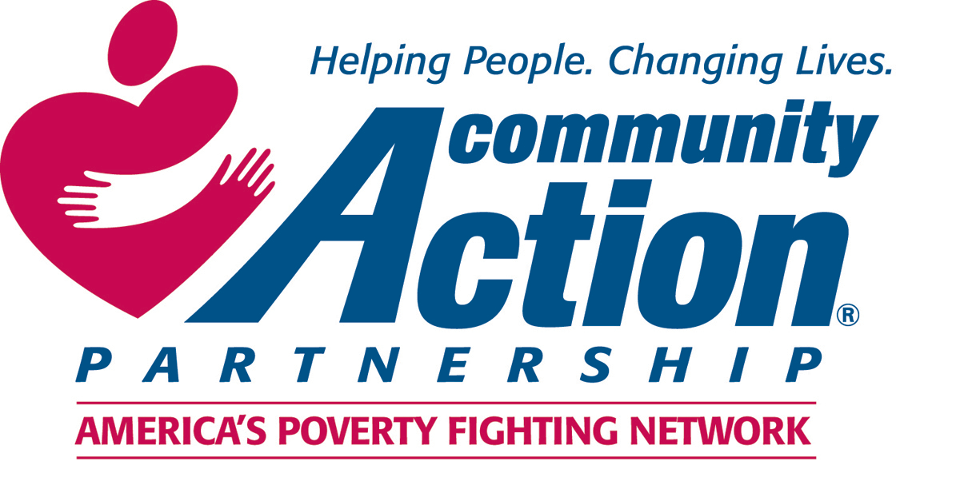
Community Action Talking Points for Commenting on
OMB Directive No. 14
“Consumer Inflation Measure Produced by Federal Statistical Agencies”

With these proposed changes to the calculation of the Official Poverty Measure, less people will qualify for Essential Federal Programs and Services Offered by Community Action…

The calculation of the Official Poverty Measure is enormously consequential to the Community Action Network. Individuals and families across the country rely on Community Action Agencies (CAAs) to access a variety of essential federal programs and funding streams, such as: Community Services Block Grant (CSBG), Head Start, Low-Income Home Energy Assistance Program (LIHEAP), and the Weatherization Assistance Program to help them make ends meet and get ahead. Eligibility for these programs is determined by the HHS Poverty Guidelines, which are derived from the Census Bureau’s Official Poverty Measure. If the calculation of the Official Poverty Measure is changed in the ways mentioned in this proposal, the threshold would decrease over time, resulting in a lower measurement of poverty for the HHS Poverty Guidelines. This means fewer people would qualify for the critical federal programs and services offered by the Community Action network, and CAAs would have less flexibility in fulfilling their purpose to move people out of poverty.

How Federal Programs and Funding Streams are affected:

CSBG
CSBG is a funding stream that provides federal resources to enable communities to address poverty at the local level. A critical anchor to CSBG is a comprehensive assessment of community needs, including an analysis of local demographic data, based on official poverty thresholds. This analysis determines the strategies and services offered by CAAs in communities across the country, and it also provides a baseline metric to be able to track changes over time. The proposed changes to the calculation of the poverty threshold would artificially lower the poverty line, and result in a less accurate measures and data. With less accurate data, CAAs will not be able to properly assess and address the needs of their community.

LIHEAP
In 2018, about 6 million low-income people were hit hard by energy bills, resulting in the need for LIHEAP assistance. In the winter months, a heating bill can cost a low-income family 25 percent of its income. Over time, shrinking the inflation adjustment for the poverty measure will mean more households will exceed the 150% federal eligibility cutoff, therefore being denied LIHEAP assistance and experiencing unsafe and unhealthy conditions during extreme hot and cold weather.

Head Start
Head Start provides comprehensive early childhood education, health, nutrition, and parent involvement services to low-income children and their families. This long running anti-poverty program has proved to be one of the most effective tools for moving children out of poverty, with consistent evidence pointing to improved long-term success of Head Start participants including decreases in teen parenthood, lower criminal engagement, as well as improved educational attainment, adult health status, and wage earnings. Head Start and Early Head Start Services are available for children from birth to age five who are from families with incomes below the poverty guidelines. Despite this demonstrated success of the program, only 31% of eligible children ages 3 - 5 had access to Head Start in 2017, and just 7% of eligible children under 3 had access to Early Head Start. By shrinking the annual inflation, a portion of the 1 million children served in 2018 would also be denied eligibility, shutting this door to opportunity to an even a greater number of American families. Struggling, working families whose earnings would just exceed the shrinking poverty guidelines would be impacted the most, resulting in an inability to afford child care and therefore barriers to keeping their jobs.

Weatherization
While states vary in the eligibility levels they set for this program to improve the energy efficiency of low-income households, the federal government sets the maximum income for eligibility at below 200 percent of the poverty guideline. Weatherization assistance is cost-effective, in that it can reduce annual heating or cooling costs. If fewer households are able to save on energy costs through Weatherization due to ineligibility from the shrinking poverty guidelines, more of them may be forced to make unhealthy trade-offs, such as cutting back or medicine or food in order to pay heating bills. Such choices would threaten the health of vulnerable children, seniors, and people with disabilities.

The impact would hit working families the hardest….
Studies suggest that costs actually may rise more rapidly for low-income families that for the population as a whole. And at the same time, households just above the official poverty line report higher than average rates of food insecurity and difficulty paying rent and utilities. They are also more likely to lack health insurance. These facts suggest that shrinking the annual rate of increase in the Official Poverty Measure will artificially push people over the poverty line even though they already struggle to make ends meet. Such a change would be unsupported by the evidence, and would have the unfortunate impact of increasing hardships for people who work at low and volatile wages, as well as for retirees whose earnings were never high and who were unable to build adequate savings.
The official poverty measure is already below what is needed to raise a family in this county; the proposed changes would move the line in the wrong direction….
Economists have long considered the official poverty measure to be outdated and imperfect. The calculation of the official poverty measure was established in the 1960’s when food costs made up one third of an average family’s after tax income. Since then, this measure has only been adjusted to reflect inflation, and does not take into account the increase of costs of other essential necessities such as housing, health care, and child care. This means the poverty line is already far below what is needed to raise a healthy family. A change in the calculation of inflation to determine the poverty threshold, as suggested in the proposal, entirely ignores this critical oversight in how the poverty measure is established, and would further result in lower and less accurate measurement overtime.
The nation’s Community Action Agencies embody our nation’s spirit of hope, change people’s lives, and improve communities. Through the aforementioned funding streams and programs, CAAs promote workable solutions that connect more families to opportunity – and make America a better place to live for everyone. It is important the eligibility for these programs and services is based on a poverty measure rooted in data and evidence for those truly in need.

